PEGround Fault

Author:Wesley
Reviewer:Eason

FAQ\EVC
Issue introduction
The error PEGround Fault on the Alarm list of the EVC.
Confirmation of basic information
[Photo] SN number of the EVC.
Guidance for installer
Use a multimeter to measure the voltage between the neutral line and the ground line.
● If the value is below 30V, restart the EVC.If the error remains,upgrade the firmware to last version.
● If the measured value exceeds 30V, carefully check whether the ground line is properly connected.
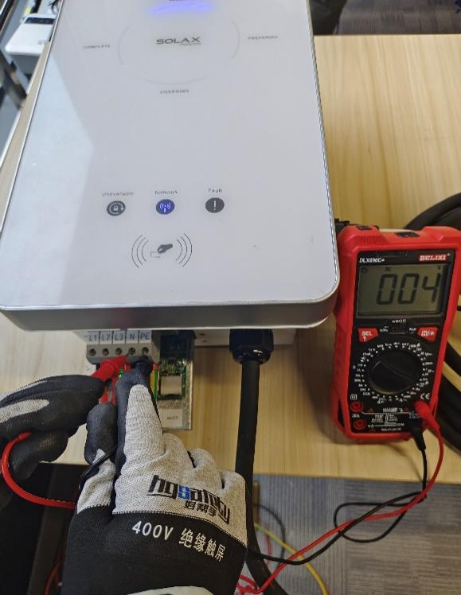
Tips：If the grid type in your area is T-T, which may causing the neutral-to-ground voltage to exceed 30V, please let us know.
Information check list
If you have completed the above <Guidance for installer>, and the problem is still not solved, please collect the following troubleshooting information and send them to the Solax technical support team
1. [Photo]EVC information including SN and registration numbers.
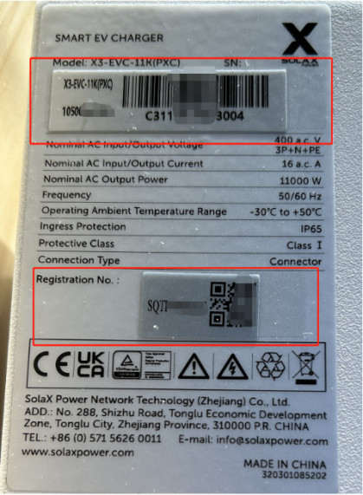
2. [Photo] The voltage between the neutral line and the ground line.
